Lab 17
Functional Dependencies
- Prove six Armstrong’s inference rules

- Prove or disprove the following inference rules for functional dependencies
a. {W → Y, X → Z} |= {WX → Y }
b. {X → Y} and Y ⊇ Z |= {X → Z }
c. { X → Y, X → W, WY → Z} |= {X → Z}
d. {XY → Z, Y → W} |= {XW → Z}
e. {X → Y, XY → Z} |= {X →Z}

- Consider the following two sets of functional dependencies
F= {A → C, AC → D, E → AD, E → H} and
G = {A → CD, E → AH}. Check whether or not they are equivalent.

- Consider the relation schema EMP_DEPT
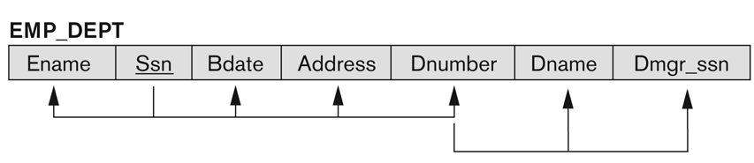
and the following set G of functional dependencies on EMP_DEPT:
G = { SSN → {ENAME, BDATE, ADDRESS, DNUMBER},
DNUMBER → {DNAME, DMGRSSN} }.
Calculate the closures {SSN}+ and {DNUMBER}+ with respect to G.

- Is the set of functional dependencies G in Exercise 4 minimal? If not, try to find an minimal set of functional dependencies that is equivalent to G. Prove that your set is equivalent to G.

- Finding key:
R (A, B, C, G, H, I)
F = { f1: A → B,
f2: A → C,
f3: CG → H,
f4: CG → I,
f5: B → H }

- Finding key:
R={A,B,C,D,E}
F = { f1: A → BC,
f2: CD → E,
f3: B → D,
f4: E → A}

